Type of Article: Research Article
Title Household Food Security and Urinary Phenols Among U.S. Adults Evidence from NHANES 2005-2016

Author Names
Ayishat Abimbola Yussuf¹, Marshae Nickelberry MPH², Izzuddin M Aris³, Michele R Hacker⁴, Emily Oken MD³, Tamarra James-Todd PhD^{2,5}

Affiliations
¹Spelman College, Atlanta, Georgia, USA
²Department of Environmental Health, Harvard T.H. Chan School of Public Health, Boston, Massachusetts, USA
³Division of Chronic Disease Research Across the Lifecourse, Department of Population Medicine, Harvard Medical School and Harvard Pilgrim Health Care Institute, Boston, Massachusetts, USA
⁴Department of Obstetrics and Gynecology, Beth Israel Deaconess Medical Center, Brookline, Massachusetts, USA
⁵Department of Epidemiology, Harvard T.H. Chan School of Public Health, Boston, Massachusetts, USA

Corresponding Author: Ayishat Yussuf
Department of Psychology, Spelman College,
350 Spelman Lane SW, Atlanta, GA, 30314, USA.
Email: ayishatyussuf@spelman.edu
Telephone: 470-522-5233

Abstract
Background. Food insecurity is a social determinant of health that may influence the exposure to endocrine-disrupting phenols through the consumption of ultra-processed foods. We examined associations between household food security and urinary phenol metabolite concentrations among a U.S. population. We assessed how these associations vary by sex and race/ethnicity using National Health and Nutrition Examination Survey (NHANES) data from 2005-2016.

Methods. The study cohort includes 10,094 adults. Household food security was established through the USDA Food Security Survey Module (FSSM) and categorized as high, marginal, low and very low food secure. Multivariable linear regressions assessed the association between household food security status and urinary phenol metabolite concentrations, adjusting for sociodemographic factors, creatinine, and cycle years. Effect measure modification by sex and race/ethnicity was evaluated.

Results. Lower food security was generally associated to lower concentrations of most urinary phenols in fully adjusted regression models, with the largest inverse associations occurring in very low food security. This included triclosan (−24.5% [95% CI: −36.8%, −9.8%]), ethyl paraben (−26.0% [95% CI: −35.1%, −15.6%]), methyl paraben (−21.5% [95% CI: −35.1%, −5.2%]), and propyl paraben (−25.1% [95% CI: −40.8%, −5.2%]). Bisphenol A phenol presented positive differences with decreasing food security but was not significant. Females, Mexican American, and non-Hispanic Black participants exhibited positive associations with some parabens.
Conclusion.
Reduced food security was associated with lower urinary phenol concentrations, with modification by sex and race/ethnicity. Future studies should further examine dietary intake among vulnerable populations to clarify associations between household food security, chemical exposures, and health outcomes.
Keywords
Phenols, household, food security, disparities, endocrine disruptors, NHANES
Introduction
In 2023, approximately 12.2 million adults experienced reduced food security or food insecurity.¹ Food security is defined as “the reliable access to adequate food for a healthy lifestyle”¹, while food insecurity refers to limited or uncertain access due to financial or resource constraints.^{1,2} Food insecurity in the United States is one of the leading social determinants of health that can heighten an individual’s risk for diet-related chronic health diseases including cardiovascular disease, diabetes, and certain cancers^{3,4}. Additional disparities are observed given the severity and scale of food insecurity experienced. On average, about one-third of households with very low food security experience chronic food insecurity, lasting roughly eight months per year.⁵ Existing literature has found that structural inequities such as systemic racism, economic disadvantage, and neighborhood-level barriers contribute to variation in the level of food insecurity experienced among households^{6–8}. Resultingly, populations with lower socioeconomic status, or marginalized racial and ethnic identities including Non-Hispanic Black and Hispanic households often face higher rates of compared to Non-Hispanic White households.^{7,9} Furthermore, gender disparities persist in regard to food insecurity as women face more food insecurity compared to men.¹⁰ These inequities reflect broader social and economic conditions that may contribute to enduring health disparities.⁷
Food insecurity often leads to changes in both the quantity and quality of food consumed, with households facing limited access to fresh, whole foods and relying more heavily on packaged, processed, and shelf-stable items.^{5,11,12} Previous literature has examined the complex relationship between food security, diet, and one’s built environment, demonstrating that food insecurity is closely linked to poorer dietary quality and greater intake of ultra-processed foods.¹² This is likely due to structural barriers including reduced access to healthy retailers¹³ such and the economic burden of affording foods with higher nutritional value.^{7,11} The intake of ultra-processed foods can lead to the ingestion of endocrine disrupting chemicals, including phenolic compounds, due to their extensive processing, packaging, and storage in materials that leach these substances into food.^{12,14} Phenol exposure is cause for concern due to its associations to metabolic processes and adverse health outcomes¹⁵.
Phenols are a class of organic chemical compounds characterized by one or more hydroxyl groups attached to an aromatic hydrocarbon ring.¹⁶ These chemicals are widely used in the manufacturing including food packaging, and as food preservatives.^{12,17} While few studies have examined food security explicitly and phenols exposure, individuals experiencing low food security are more likely to depend on packaged foods and meals from convenience stores due to economic constraints and limited access to fresh produce. Studies of ultra-processed and fast-food consumption show that these dietary patterns are associated with higher urinary concentrations of several phenols such as bisphenol A (BPA) and bisphenol F (BPF)^{12,18}.
Despite these findings, a key research gap remains in understanding the chemical exposure pathways linking household food insecurity and endocrine disrupting chemicals, specifically phenol metabolite exposures. Understanding this connection is important for identifying environmental health disparities and the broader health impacts of household food insecurity.¹⁹ This study examines the association between household food security and urinary phenol metabolite concentrations, cross-sectionally using National Health and Nutrition Examination Survey data from 2005-2016. We also seek to explore whether race/ethnicity as well as will sex modify this association. We hypothesize that reduced household food security will be associated with increased urinary phenol metabolite concentrations among adults, and that sex and race/ethnicity will modify these associations.

Methods

Study Design
This study utilized cross sectional data from the National Health and Nutrition Examination Survey (NHANES), a US based population. NHANES is administered through the Centers of Disease Control and Prevention (CDC), and conducts interviews, physical examinations and laboratory tests on a random sample of eligible study participants, utilizing one participant from each household.^{20,21} NHANES uses a complex, multistage sampling method with oversampling of selected population subgroups. Details on data collection is made available elsewhere.^{20,21} We utilized data from the 2005-2016 NHANES cycle years, where phenols of interest were consistently measured. From our initial cohort (n=16,349), individuals were eligible for inclusion in our study if they were 18 years of age or older (n=11,479), had available urinary phenol metabolite, household food security, and sociodemographic information (n=10,423). Our final analytic study population consisted of 10,094 adult participants with complete exposure, outcome and covariate data. (Supplemental Figure 1).
Household Food Security
Household food security was measured using the U.S. Department of Agriculture’s (USDA) Food Security Survey Module (FSSM), a well-validated 18-item questionnaire.²² Questionnaires were administered in participant’s home by an NHANES personnel, using computer assisted personal interview technology.^{20,23} Based on the survey module’s responses, a categorical variable was created with four household food security categories: high food security (reference), marginal food security, low food security, and very low food security.²² For the remainder of this paper, we will simply refer to food security levels as high, marginal, low, and very low food security.
Urinary Phenol Metabolite Concentrations
NHANES measured urinary phenol metabolite concentrations (ng/mL) by collecting spot urine samples, assayed by the CDC National Center for Environmental Health Laboratory, utilizing solid phase extraction in conjunction with high performance liquid chromatography electrospray ionization tandem mass spectrometry (HPLC-ESI-MS/MS)27.²⁴ Since phenols are rapidly metabolized and excreted in urine, we utilized urinary phenol metabolites as biomarkers of exposure rather than parent compounds to minimize potential exposure misclassification.^{16,25,26} We initially identified nine urinary phenol metabolites for the study analysis and removed metabolites that were not consistently found across cycle years or had detection frequencies below 50%. We restricted our analysis to six urinary phenol metabolites measured across 2005-2016 cycle years: urinary Bisphenol A (BPA), urinary 2-Hydroxy-4-methoxybenzophenone or benzophenone-3 (BP3), urinary 2,4,4’-Trichloro-2’-hydroxyphenyl ether or Triclosan (TRS), urinary Ethyl Paraben (EPB), urinary Methyl Paraben (MPB), and urinary Propyl Paraben (PPB). We used limit of detection values across cycle years reported by NHANES²⁵, for each urinary phenol. Values below the lower limit of detection (LLOD)were substituted with LLOD$√$2 by NHANES.²⁷ Urinary phenol concentrations were corrected for specific gravity to account for urine dilution.²⁷

Covariates

Covariates were identified a priori using existing literature^{12,26,28} and directed acyclic graphs (DAGs) to identify potential confounders of the association between urinary phenol metabolite concentrations and household food security. Covariate data were obtained from computer-assisted demographic questionnaires administered by NHANES personnel.²⁰ We included self-reported age, sex, race/ethnicity, highest educational attainment, and poverty income ratio (PIR) as covariates of interest. Self-reported age was measured continuously and later categorized in quartiles according to the sample distribution. Highest educational attainment was initially categorized as (less than 9th grade, 9th-11th grade, high school grad/GED or equivalent, some college or AA degree, college graduate or above) and was later recategorized as (< 9th grade, high school graduate or equivalent, some college, ≥ college) due to small stratum sizes. Sex (male/female) and race/ethnicity (non-Hispanic white, non-Hispanic Black, Mexican American, other Hispanic, other race – including Multi-Racial) were measured as categorical variables, and analytic categories were consistent with NHANES categorizations. Similarly, PIR is calculated by NHANES using U.S. Department of Health and Human Services poverty guidelines²⁰. We additionally created survey cycle year as a categorical variable to account for temporal differences across cycles.²⁹ Urinary creatinine concentration (ng/mL) was included to adjust for urinary dilution, consistent with prior NHANES-based analyses.²⁵

Statistical Analysis

Descriptive statistics including frequencies (percentages) and means were calculated to analyze the analytic study populations’ sociodemographic factors and other covariate groups by household food security status. Urinary phenol metabolite concentrations were log normally distributed and later natural log transformed. Detection percentages, geometric means (GM) and the 25th and 75th percentile were reported. Spearman correlation coefficients were used to assess correlations between individual metabolites. For our main analysis we used multivariable linear regression models to evaluate the association between log transformed urinary phenol concentrations and food security levels. We first ran urinary creatinine-adjusted models only followed by models adjusted for our confounders of interest. Covariates in fully adjusted models were defined according to their NHANES categorization: sex (female (ref), male), education level (< 9th grade, high school graduate or equivalent, some college, ≥ college), age (continuous), race/ethnicity (non-Hispanic White (ref), non-Hispanic Black, Mexican American, other Hispanic, Other including Multi-Racial), poverty income ratio (0-0.99, 1-1.99, 2-2.99, 3-4.99, and 5.0 or greater). We also included a generated cycle year variable (2005-2006, 2007-2008, 2009-2010, 2011-2012, 2013-2014, and 2015-2016) as well as measured urinary creatinine. Exponentiated estimated coefficients were presented as the percent (%) difference, computed as 100*(exp(β)-1). Higher concentrations in the comparison group (marginal, low, and very low food security) to the reference group (high food security) indicated a positive percent differences; negative percent differences indicated lower concentrations.
To assess potential effect measure modification by sex, race, and ethnicity, household food security was modeled categorically as a nominal variable with a product term for household food security status*sex and household food security*race and ethnicity respectively. Estimated adjusted marginal means were extracted and reported as percent differences by sex or race and ethnicity. Next, to test for overall interaction, and obtain a p_{interaction} for each analyte, we modeled the four-level household food security variable as an ordinal variable, with a single cross-product term, assuming equal spacing between categories and linear trends across categories. We then examined whether these linear trends across ordinal categories of household food security, differed by sex or race and ethnicity for each analyte. We used a conservative p-value of $<$0.10 for statistical significance. All statistical analyses were performed in R studio 4.5.1.

Table 1: Unweighted Demographic Characteristics of the Analytic Study Population
 | Full (Ref)  N=7,019 | Marginal  N=1,136 | Low  N=1,218 | Very Low  N=721 | Overall  (N=10,094)
 | N (%) | N (%) | N (%) | N (%) | N (%)
Sex
Male | 3509 (50) | 533 (46.9) | 569 (51.5) | 569 (46.7) | 4,954 (49.1)
Female | 3,510 (50.0) | 603 (53.1) | 649 (53.3) | 378 (52.4) | 5,140 (50.9)
Age (years) | 49 (19) | 42 (18) | 42 (17) | 42 (16) | 47 (19)
Race/Ethnicity
NH White | 3,412 (48.6) | 345 (30.4) | 318 (26.1) | 250 (34.7) | 4,325 (42.8)
NH Black | 1,441 (20.5) | 297 (26.1) | 331 (27.2) | 194 (26.9) | 2,263 (22.4)
Mexican-American | 868 (12.4) | 267 (23.5) | 294 (24.1) | 139 (19.3) | 1,568 (15.5)
Other Hispanic | 520 (7.4) | 126 (11.1) | 165 (13.5) | 95 (13.2) | 906 (9.0)
Other, incl. Multi-Racial | 778 (11.1) | 101 (8.9) | 110 (9.0) | 43 (6.0) | 1,032 (10.3)
Highest Educational Attainment
Less than 9th Grade | 1,382 (19.7) | 396 (34.9) | 504 (41.4) | 284 (39.4) | 2,566 (25.4)
High School Graduate or Equivalent | 1,730 (24.6) | 320 (28.2) | 327 (26.8) | 197 (27.3) | 2,574 (25.5)
Some College | 1,939 (27.6) | 313 (27.6) | 303 (24.9) | 210 (29.1) | 2,756 (27.4)
College or Above | 1,968 (28.0) | 107 (9.4) | 84 (6.9) | 30 (4.2) | 2,189 (21.7)
Poverty Income Ratio
Low Poverty | 993 (14.1%) | 397 (34.9%) | 528 (43.3%) | 375 (52.0%) | 2,293 (22.7%)
Near Poverty | 1,560 (22.2%) | 405 (35.7%) | 458 (37.6%) | 262 (36.3%) | 2,685 (26.6%)
Middle Income | 1,085 (15.5%) | 178 (15.7%) | 127 (10.4%) | 53 (7.4%) | 1,443 (14.3%)
Upper-Middle Income | 1,679 (23.9%) | 124 (10.9%) | 91 (7.5%) | 27 (3.7%) | 1,921 (19.0%)
High Income | 1,702 (24.2%) | 32 (2.8%) | 14 (1.1%) | 4 (0.6%) | 1,752 (17.4%)
Cycle Year
2005–2006 | 1,179 (16.8) | 154 (13.6) | 148 (12.2) | 70 (9.7) | 1,551 (15.4)
2007–2008 | 1,313 (18.7) | 175 (15.4) | 168 (13.8) | 93 (12.9) | 1,749 (17.3)
2009–2010 | 1,246 (17.8) | 197 (17.3) | 234 (19.2) | 148 (20.5) | 1,825 (18.1)
2011–2012 | 1,109 (15.8) | 195 (17.2) | 192 (15.8) | 127 (17.6) | 1,623 (16.1)
2013–2014 | 1,203 (17.1) | 199 (17.5) | 218 (17.9) | 138 (19.1) | 1,758 (17.4)
2015–2016 | 969 (13.8) | 216 (19.0) | 258 (21.2) | 145 (20.1) | 1,588 (15.7)
- Unweighted descriptive statistics count (frequency) and proportion (percentage) per food security category reported.

Study Population
A total of 10,094 adults were included in the final analytic study (Table 1). Participants were approximately evenly distributed by sex (male 49.1%, female: 50.9%). The median age was 47 years overall; adults with reduced food security (marginal, low and very low) were on average younger (n=42 years) than those with high food security (n=49 years). Non-Hispanic White adults were the largest racial/ethnic group overall (42.8%), followed by Non-Hispanic Black (22.4%) and Mexican American (15.5%). but were distributed differently across food security categories. Among adults with low food security, non-Hispanic Black (27.2%) and Mexican- American (24.1%) participants represented the largest proportions, whereas non-Hispanic White adults remained the largest group in high, marginal and very low categories. Compared with adults with high food security (19.7%), participants with marginal, low and very low security had lower educational attainment, with a higher proportion having less than 9th grade (marginal: 34.9%, low: 41.4%%, very low: 39.4%%). Similarly, across food security groups, those with marginal, low, and very low were more likely to live in low- or near-poverty households compared with adults with high food security.

Table 2: Detection Frequency and Distribution of Urinary Phenol
Concentrations (ng/mL)
Urinary Metabolite | Abbreviation | %>LOD | 25th | GM | 75th
Bisphenol A | BPA | 92% | 0.69 | 1.52 | 3.10
2-Hydroxy-4-metoxybenzophenone | Benzophenone-3 | 96% | 4.71 | 21.05 | 76.71
2,4,4’-Trichloro-2’-hydroxyphenyl ether | Triclosan | 75% | 1.80 | 12.22 | 49.40
Ethyl paraben | EPB | 50% | 0.71 | 2.51 | 6.70
Methyl paraben | MPB | 99% | 13.33 | 51.21 | 192.50
Propyl paraben | PPB | 95% | 1.11 | 6.72 | 40.90
- %>LOD represents the limit of detection of phenol metabolite concentrations. Values below the detection limit are imputed as LOD $\sqrt{2}$by NHANES. The 25th and 75th percentiles are log-transformed. GM represents the geometric mean.

Detection Frequency and Distribution
Most urinary phenol metabolite concentrations had detection frequencies 90% of higher with the exception of ethyl paraben (50%) and triclosan (75%). Methyl paraben had the highest geometric mean of 51.21 ng/mL, while Bisphenol A was the lowest geometric mean of 1.52 ng/mL. All phenols were positively correlated with modest correlations between methyl paraben and propyl paraben (Spearman ρ= 0.82). (Supplemental Figure 2).

Table 3: Adjusted Linear Regression: Self-Reported Food Security Status and Urinary Phenol Metabolites
Phenol Metabolite | Food Security Level | % Difference | 95% CI
BPA | High (Ref)
 | Marginal | 1.80 | -5.91 | 10.15
 | Low | 7.53 | -1.27 | 17.12
 | Very Low | 7.61 | -4.48 | 21.23
BP3 | High (Ref)
 | Marginal | -19.82 | -31.68 | -5.91
 | Low | -17.40 | -29.05 | -3.84
 | Very Low | -19.55 | -35.27 | -0.02
TRS | High (Ref)
 | Marginal | -14.72 | -28.86 | 2.22
 | Low | -12.65 | -25.06 | 1.80
 | Very Low | -24.46 | -36.76 | -9.77
$$EPB$$ | High (Ref)
 | Marginal | -10.97 | -21.90 | 1.50
 | Low | -5.65 | -17.98 | 8.53
 | Very Low | -25.96 | -35.07 | -15.57
$$MPB$$ | High (Ref)
 | Marginal | -16.65 | -26.78 | -5.10
 | Low | -14.81 | -28.35 | 1.29
 | Very Low | -21.53 | -35.05 | -5.18
$$PPB$$ | High (Ref)
 | Marginal | -16.26 | -28.75 | -1.59
 | Low | -15.16 | -32.01 | 5.85
 | Very Low | -25.08 | -40.79 | -5.20

- Values are adjusted percent differences in urinary phenol metabolite concentrations (ng/mL) compared to the High Food Secure category (reference group) based on multivariable linear regression models. adjusted for age, gender, education, cycle year, race/ethnicity, poverty-to-income ratio and creatinine.
- 95% LCI= 95% lower confidence interval; 95% UCI= 95% upper confidence interval.
- Abbreviations: BPA =Bisphenol A; BP3 =Bbenzophenone-3; TRS = 2,4,4’-Trichloro-2’-hydroxyphenyl ether; EPB = ethyl paraben; MPB = methyl paraben; PPB = propyl paraben.

Main Analysis
In creatinine adjusted models, reduced food security was associated with higher levels of BP3, TRS, and PPB compared to the reference. For instance, very low food security was associated with positive percent difference in BP3 (10.42%), TRS (27.84%) and PPB (20.60%) (Supplemental Table 1). Reduced food security was generally associated with negative percent differences for remaining compared to high food secure levels.
In adjusted analysis, several of these trends did not persist and food security was negatively associated with most urinary phenols indicating reduced food security was associated with lower metabolite levels compared to high food secure individuals. Benzophenone-3 (BP3) levels were lower among individuals with marginal (-19.8% [95% CI: -31.7%, 5.9%]), low (-17.4% [95% CI: -29.1%, -3.8%]), and very low (-19.6% [95% CI: 35.3%, 0.02%]) food security groups compared to participants with high food security. While estimates for triclosan, and all parabens similarly suggested lower levels with reduced food security status, very low food security consistently showed the largest percent differences. Specifically, compared to individuals with high food security, very low food insecure individuals had significantly lower levels of triclosan (-24.46%, [95% CI: -36.76%, -9.77%]), ethyl paraben(-25.96%, [95% CI: -35.07%, -15.57%] , methyl paraben (-21.53%, [95% CI: -35.05%, -5.18%], and propyl paraben (-25.08%, [95% CI: -40.79%, -5.20%]. Additional associations with marginal food security for some not all parabens were observed. (Figure 1, Table 3). In contrast, BPA was the only urinary phenol with positive % differences, suggesting higher concentrations with decreasing food security; however, all CIs contained the null (Figure 1, Table 3).

Figure 1: Household Food Security Associations with Urinary Phenol Concentrations
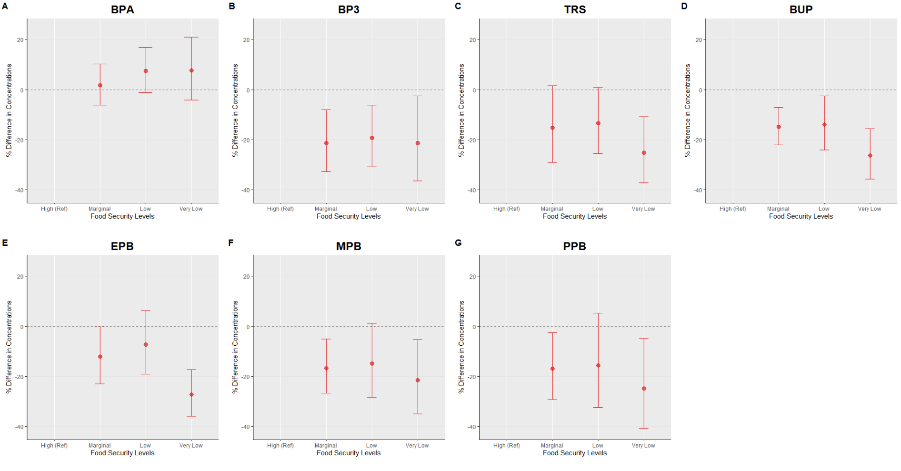
- Panels A–G represent adjusted percent differences in urinary phenol metabolite concentrations. Reference is High Food Secure. Circles represent estimated percent differences; bars represent 95% confidence intervals. All models are adjusted for age, sex education, race/ethnicity, poverty-income ratio, cycle year, and creatinine.

Figure 2: Strata Specific Adjusted Linear Regression Plot: Self-Reported Food Security Status and Urinary Phenol Metabolites with Sex Interaction
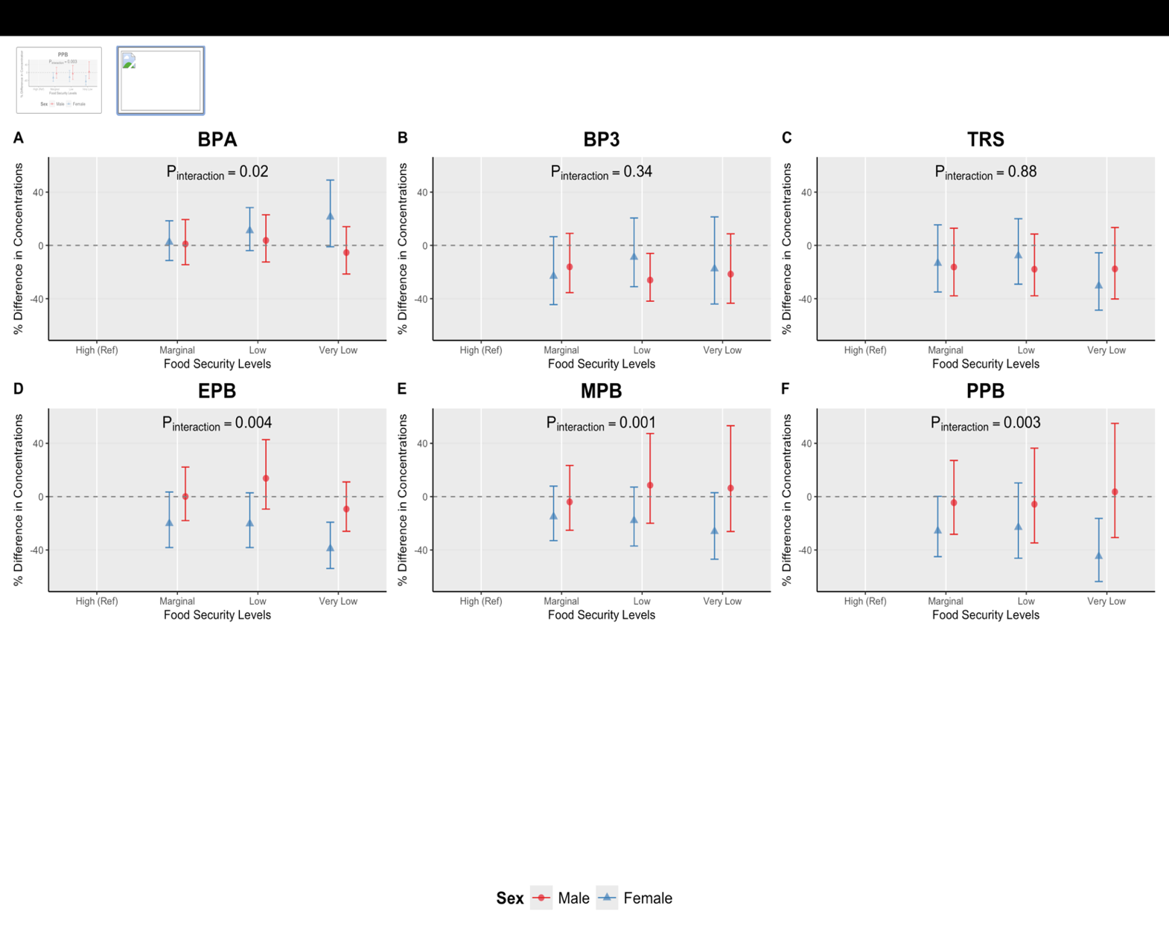
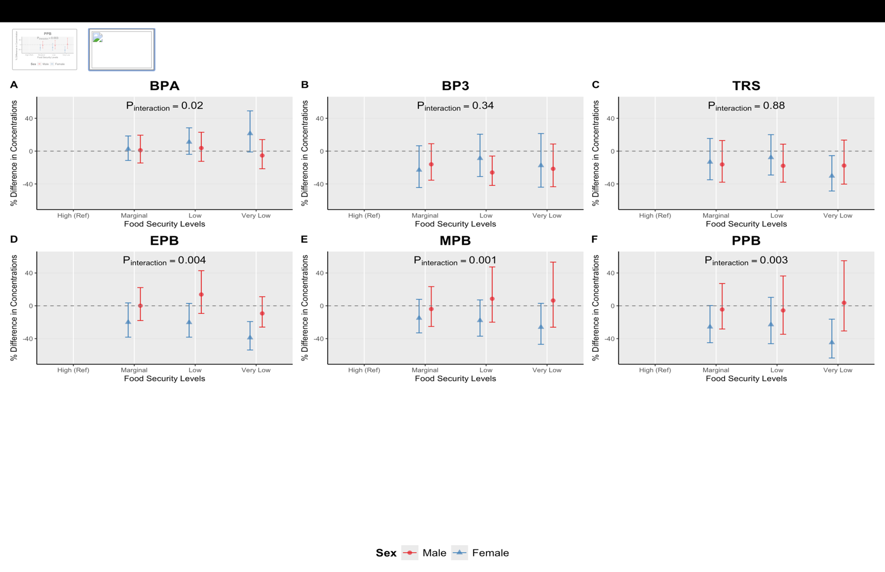
- Sex stratified adjusted percent differences (95% confidence intervals) in urinary phenol metabolite
- Concentrations across food security levels, estmated from multivariable linear regression models adjusted for age, race and ethnicity, education, survey cycle, poverty-to-income ratio and creatinine. High Food Secure is the reference group.
- P_{interaction} values are reported from food security*sex interaction models, where food security is modeled as continuous variable.

Effect Measure Modification by Sex
Next, we assessed potential effect measure modification by sex. There was evidence of interaction for BPA (p_{interaction}=0.02), and all parabens (ethyl (p_{interaction}<0.01), methyl (p_{interaction} <0.01), propyl (p_{interaction}<0.01). In stratum specific models, we estimated marginal means and reported percent differences.
For BPA estimates, both females and males exhibited positive differences with reduced food security exposure, although the association appeared to be slightly stronger among females. Specifically, females experiencing low (1.08%; [95% CI: -3.9%, 28.41%]); and very low food security (very low: 21.45%; [95% CI: -1.04%, 49.05%]) had higher BPA concentrations compared with females with high food security. Among males, estimates hovered around the null and were slightly lower among very low males (-5.35%; [95% CI: -21.46%, 14.06%]). compared to males experiencing high food security (Figure 2, Supplemental Table 2).
Percent differences for parabens remained mostly negative within stratum of sex, and associations were stronger amongst females. Among females experiencing high food security, ethyl paraben concentrations were lower for marginal (20.04% [95% CI: −38.24%, −3.51%]); low (20.29% [95% CI: −38.25%, −2.89%]) and very low (38.94% [95% CI: −53.86%, −19.21%]) food secure females. Similar trends were observed for methyl paraben (marginal: -14.99%; [95% CI:-33.01%, 7.87%]; low: -17.85%; [95% CI: -37.03%, 7.18%]; very low: -26.10%; [95 CI: -46.97%, 2.98%]), and propyl paraben (marginal: (-25.71%; [95% CI:-44.96%, 0.27%%]; low: -22.96%; [95% CI: -46.20%, 10.31%]; very low: -44.82%; [95 CI: -63.63%, 16.28%]). In contrast, among males with some but not all reduced food security categories, higher levels were observed for ethyl (low: 13.79%; [95% CI: -9.33%, 42.78%]), and methyl paraben (low: 8.59%, [95% CI: -19.99%, 47.37%; very low: 6.41% [95% CI: -26.1%, 53.22%]) relative to the reference. (Figure 2, Supplemental Table 2)

Figure 3: Strata-Specific Adjusted Linear Regression Plot: Self-Reported Food Security Status and Urinary Phenol Metabolites with Race and Ethnicity Interaction 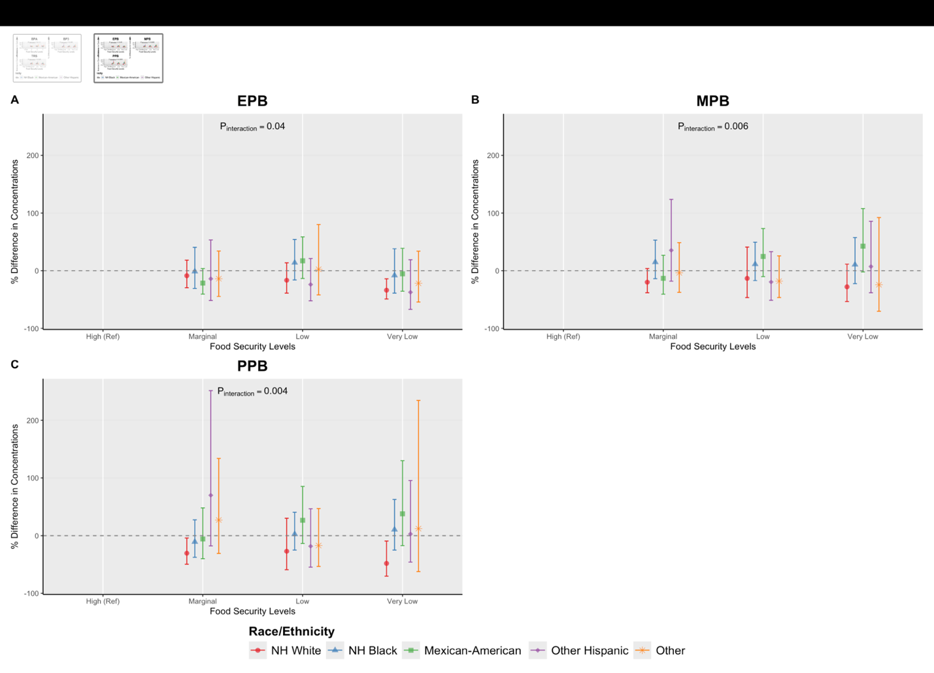
- Race stratified adjusted percent differences (95% confidence intervals) in urinary phenol metabolite concentrations across food security levels, estmated from multivariable linear regression models adjusted for age, sex, education, survey cycle, poverty-to-income ratio and creatinine. High Food Secure is the reference group.
- P_{interaction} values are reported from food security*race and ethnicity interaction models, where food security is modeled as continuous variable.
- NH White: Non Hispanic White; NH Black: Non-Hispanic Black

Effect Measure Modification by Race/Ethnicity
Finally, we assessed potential effect measure modification by race and ethnicity (Supplemental Tables 3-9). There was evidence of interaction all parabens, ethyl (p_{interaction}=0.04), methyl (p_{interaction}<0.01), and propyl (p_{interaction} <0.01). Among non-Hispanic White individuals, reduced food security (marginal, low, and very low) was associated with lower levels of parabens. Non-Hispanic White individuals experiencing very low food secure participants had the largest negative difference (i.e. lowest levels) compared to non-Hispanic White adults with high food security (e.g. ethyl paraben concentrations: very low: -33.81% [95% CI: -49.12%, -13.90%]).
In contrast, Mexican-American participants experiencing low or very low food security generally had higher levels of parabens. For instance, relative to Mexican-Americans with high food security, methyl parabens estimates were lower among Mexican-Americans experiencing low (24.69% [95% CI: -10.20,73.13%]) and lower among those experiencing very low food security (42.53% 95% CI [-2.18, 107.69%]) (Figure 3, Supplemental Table 8). Among non-Hispanic Black individuals’ results were similar to those among non-Hispanic Black adults with low food security generally showing the largest positive percent difference for ethyl (low: 13.88% [95% CI: -15.89%, 54.18%) (Figure 3, Supplemental 7) methyl (low: 11.32% [95% CI: -17.07%, 49.43%]) (Figure 3, Supplemental 8) and propyl (low: 2.65% [95% CI: -15.89%, 54.18%]; very low: 10.44% [95% CI: -25.02%, 62.29%]) (Figure 3, Supplemental 9) parabens. Among other Hispanic and Other-race adults, associations between reduced food security and paraben concentrations appeared to be positive for some, but not all parabens; however, results were mixed overall.

Discussion

Strengths
This study exhibited several strengths. The extensive NHANES dataset spanned an 11-year period and examined six urinary phenol metabolite concentrations. The study population was representative of multiple sociodemographic characteristics, enhancing generalizability. The collection and laboratory analysis of urine samples by the CDC National Center for Environmental Health Laboratory further strengthened exposure assessment, alongside the use of the well-validated 18-item gold standard USDA Food Security Survey Module (FSSM) to categorize household food security. Multivariable linear regression models were used to adjust for relevant covariates, including race/ethnicity, age, sex, poverty-income ratio, cycle year, and creatinine. Additionally, stratified analyses by race/ethnicity and sex allowed us to examine effect modification in the associations between race/ethnicity * household food security status, as well as sex * household food security status, with findings supporting existing literature^{6,8,10}.

Limitations
Several limitations should be considered. Self-reported measures are subject to minimal nondifferential misclassification toward the null and potential bias. The cross-sectional study design limits the determination of temporality between the exposure and outcome. Future studies should employ longitudinal designs to follow participants over time and assess exposures and outcomes prospectively. Phenol concentrations observed in some individuals may be influenced by sources such as personal care products, making it uncertain whether food packaging represents the primary exposure source. Exposure may also occur through non-dietary pathways, such as inhalation, and further investigation into food systems contributing to packaging and handling is warranted. Finally, the NHANES cycle years used in this study are not recent due to the unavailability of urinary phenol metabolite data in later cycles (approximately 10 years old at present); future research should incorporate more recent data as they become available.
References

1. Rabbitt M, Hales L, Reed-Jones, M. Food Security in the U.S. - Definitions of Food Security. United States Department of Agriculture; 2025. https://www.ers.usda.gov/topics/food-nutrition-assistance/food-security-in-the-us/definitions-of-food-security
2. Berkowitz SA, Seligman HK, Palakshappa D. Understanding food insecurity risk in the United States: A longitudinal analysis. SSM - Popul Health. 2024;25:101569. doi:10.1016/j.ssmph.2023.101569
3. Vercammen KA, Moran AJ, McClain AC, Thorndike AN, Fulay AP, Rimm EB. Food Security and 10-Year Cardiovascular Disease Risk Among U.S. Adults. Am J Prev Med. 2019;56(5):689-697. doi:10.1016/j.amepre.2018.11.016
4. Maynard M, Andrade L, Packull-McCormick S, Perlman CM, Leos-Toro C, Kirkpatrick SI. Food Insecurity and Mental Health among Females in High-Income Countries. Int J Environ Res Public Health. 2018;15(7):1424. doi:10.3390/ijerph15071424
5. Rabbitt M, Reed-Jones, M, Hales L, Burke M. Household Food Security in the United States in 2023. United States. Department of Agriculture. Economic Research Service.; 2024. doi:https://doi.org/10113/8583175
6. Wang H, El-Abbadi N. Food Insecurity, Race and Ethnicity, and Cognitive Function Among United States Older Adults. J Nutr. 2024;154(1):233-242. doi:10.1016/j.tjnut.2023.11.015
7. Odoms-Young A, Brown AGM, Agurs-Collins T, Glanz K. Food Insecurity, Neighborhood Food Environment, and Health Disparities: State of the Science, Research Gaps and Opportunities. Am J Clin Nutr. 2024;119(3):850-861. doi:10.1016/j.ajcnut.2023.12.019
8. Mobley C, Luo Y, Fernandez M, Hossfeld L. Social Determinants of Health and College Food Insecurity. Nutrients. 2024;16(9):1391. doi:10.3390/nu16091391
9. Cowan-Pyle AE, Bailey RL, Gao J, et al. Dietary Quality and Diet-Related Factors Among Emerging Adults (18-23 y) in the United States Are a Cause for Concern: National Health and Nutrition Examination Survey 2015-2018. J Nutr. 2024;154(8):2524-2533. doi:10.1016/j.tjnut.2024.06.015
10. Ma C, Ho SKM, Singh S, Choi MY. Gender Disparities in Food Security, Dietary Intake, and Nutritional Health in the United States. Am J Gastroenterol. 2021;116(3):584-592. doi:10.14309/ajg.0000000000001118
11. Yates J, Deeney M, Rolker HB, White H, Kalamatianou S, Kadiyala S. A systematic scoping review of environmental, food security and health impacts of food system plastics. Nat Food. 2021;2(2):80-87. doi:10.1038/s43016-021-00221-z
12. Buckley JP, Kim H, Wong E, Rebholz CM. Ultra-processed food consumption and exposure to phthalates and bisphenols in the US National Health and Nutrition Examination Survey, 2013-2014. Environ Int. 2019;131:105057. doi:10.1016/j.envint.2019.105057
13. Ziso D, Chun OK, Puglisi MJ. Increasing Access to Healthy Foods through Improving Food Environment: A Review of Mixed Methods Intervention Studies with Residents of Low-Income Communities. Nutrients. 2022;14(11):2278. doi:10.3390/nu14112278
14. Ruggiero E, Di Castelnuovo A, Costanzo S, et al. Dietary Polyphenol Intake in Relation to Ultra-Processed Food Consumption in a Mediterranean Population-Based Cohort: Findings from the Moli-Sani Study. In: The 14th European Nutrition Conference FENS 2023. MDPI; 2024:168. doi:10.3390/proceedings2023091168
15. Martínez Steele E, Khandpur N, Da Costa Louzada ML, Monteiro CA. Association between dietary contribution of ultra-processed foods and urinary concentrations of phthalates and bisphenol in a nationally representative sample of the US population aged 6 years and older. Foo LH, ed. PLOS ONE. 2020;15(7):e0236738. doi:10.1371/journal.pone.0236738
16. Phenols/Phenoxy Acids. Agency for Toxic Substances and Disease Registry; 2008. https://wwwn.cdc.gov/tsp/substances/ToxChemicalListing.aspx?toxid=40
17. Xu Z, Tian L, Liu L, Goodyer CG, Hales BF, Bayen S. Food Thermal Labels are a Source of Dietary Exposure to Bisphenol S and Other Color Developers. Environ Sci Technol. 2023;57(12):4984-4991. doi:10.1021/acs.est.2c09390
18. Martínez Steele E, Khandpur N, da Costa Louzada ML, Monteiro CA. Association between dietary contribution of ultra-processed foods and urinary concentrations of phthalates and bisphenol in a nationally representative sample of the US population aged 6 years and older. PloS One. 2020;15(7):e0236738. doi:10.1371/journal.pone.0236738
19. Gee GC, Payne-Sturges DC. Environmental health disparities: a framework integrating psychosocial and environmental concepts. Environ Health Perspect. 2004;112(17):1645-1653. doi:10.1289/ehp.7074
20. NHANES - About the National Health and Nutrition Examination Survey. 2023. https://www.cdc.gov/nchs/nhanes/about_nhanes.htm
21. National Health and Nutrition Examination Survey, 2015−2018: Sample Design and Estimation Procedures. Published online April 2020. https://www.cdc.gov/nchs/data/series/sr_02/sr02-184-508.pdf
22. Food Security in the U.S. - Survey Tools. United States Department of Agriculture (USDA); 2026. https://www.ers.usda.gov/topics/food-nutrition-assistance/food-security-in-the-us/survey-tools
23. NHANES 2019-2020 Questionnaire Data Overview. Published online National Health and Nutrition Examination. https://wwwn.cdc.gov/nchs/nhanes/continuousnhanes/overviewquex.aspx?BeginYear=2019
24. Metabolites of phthalates and phthalate alternatives. https://wwwn.cdc.gov/nchs/data/nhanes/public/2017/labmethods/PHTHTE-J-MET-508.pdf
25. Environmental Phenols (EPH_E). Published online 2011. https://wwwn.cdc.gov/Nchs/Data/Nhanes/Public/2007/DataFiles/EPH_E.htm
26. James-Todd T, Stahlhut R, Meeker JD, et al. Urinary phthalate metabolite concentrations and diabetes among women in the National Health and Nutrition Examination Survey (NHANES) 2001-2008. Environ Health Perspect. 2012;120(9):1307-1313. doi:10.1289/ehp.1104717
27. Personal Care and Consumer Product Chemicals and Metabolites (EPHPP_I). Published online January 2019. https://wwwn.cdc.gov/Nchs/Data/Nhanes/Public/2015/DataFiles/EPHPP_I.htm
28. Hartle JC, Navas-Acien A, Lawrence RS. The consumption of canned food and beverages and urinary Bisphenol A concentrations in NHANES 2003-2008. Environ Res. 2016;150:375-382. doi:10.1016/j.envres.2016.06.008
29. NHANES Demographics Variable List. https://wwwn.cdc.gov/nchs/nhanes/search/variablelist.aspx?Component=Demographics&Cycle=

